Background material for study materials

Purpose and outline
The purpose of this work is to give insight into the operation environment of a shunting yard, which can be used as learning material for logistic students. At first there is an overview of the rail freight operational market in Sweden followed by strong points of Swedish railway system. After that, a section presents the advantages of using simulators for both training and research, and a few examples are presented.

Overview of the rail freight operational market in Sweden
Sweden accounts for about 90 percent of EU production of iron ore and for about 10 percent of the total EU countries paper consumption. In addition, Sweden is responsible for about 20 per cent of the consumption of sawn timber products within the EU. Main freight operation companies in Sweden are Green Cargo and Hector Rail.
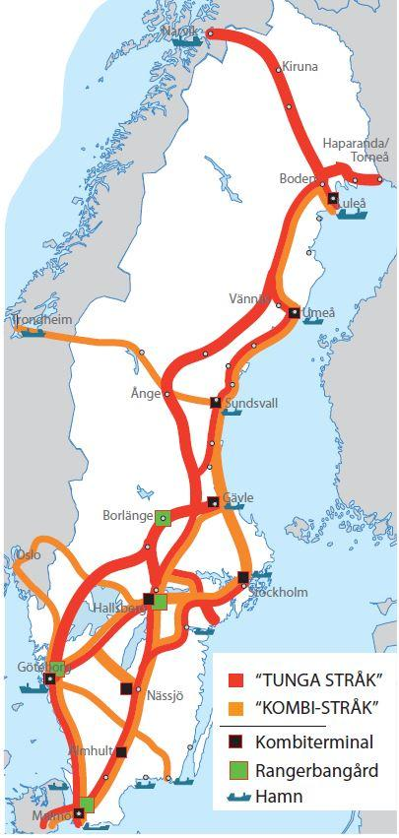
Figure 1 Overview of Swedish freight train stretches. Red indicates heavy stretches, orange combined stretches, black combined terminals and green railway yards.
Railway's market share of long-distance transport, measured in produced tonne-kilometers, is about 25 percent (year 2008). Road transport and shipping each account for approximately 38 percent of the transport work during the same period. The volume of Swedish freight transport is dominated by volume of export products linked to the mining industry and the forest industry and imported energy raw materials (oil products etc.). The heavy part of the freight transport has given the Swedish freight transport market a special touch.
Today's rail networks are large on several stretches deficiencies in capacity, carriage weights, meter weights, speed standard etc. In addition, there is a large variety of in terms of possible load profile, signal system and deflecting opportunities. The capacity of Sweden's primary freight transport network will be expanded by 50 percent by year 2025 to meet the industry's need for effective good quality transport. Investment in the national rail network for freight traffic is also necessary to create the conditions for one climate-friendly freight transport systems. For an overview of Swedish freight train stretches, see Figure 1.

Strong points of Swedish railway system
The increased specialization and internationalization in the manufacturing industry makes the processing chain from raw materials to finished product often runs through several countries before the product reaches the end consumer. Logistics needs to be streamlined, the border obstacles reduced, and transport is coordinated. A great potential in the near future is increasing flows from / to Northern Finland's heavy base industries, which are increasingly included in the same groups and processing chains as Swedish business. At the same time, flows from / to the northwest increase Russia and northern Norway.
The free movement of goods, services and people are a key prerequisite for the EU's internal market. Insufficient capacity, lack of efficiency and bottlenecks in the functioning of the transport system in many of the EU's regions impair competitiveness. The purpose of the EU transport policy is to transport infrastructure will take care of society's economic, social and environmental needs. A well-functioning one transport systems are crucial for Europe's future prosperity and is of great importance for both financial growth and social development as for the environment and climate.
The EU is working to reduce bottlenecks internationally the transport system within the EU. This work takes place within the framework of the trans-European networks (TEN-T). To speed up the work of removing the most important ones the bottlenecks, the EU has produced a list of 30 priority routes. These routes have been supplemented with a number of transnational axes, partly for the EU enlargement, partly to better connect the most important the links in the trans-European networks with neighboring countries.
The concept of Green corridors originated in initiative of the European Commission to develop a greener transport policy that meets the climate challenge and at the same time, the EU's competitiveness is increasing. See Figure 2. Sweden contributes to the development of transport strongly driven forward in collaboration. To show off efficient transport solutions are a way to move forward. Investments in the heavy goods lines are necessary to create the conditions for a more climate friendly goods transport.
The strategic position of the Baltic Sea enables growth-generating transport between countries. Crucial development factor becomes intermodality between transports on land and the ports of the Baltic Sea. The national freight stretches, with links to the many ports, allows for efficient collaboration between trains and shipping.
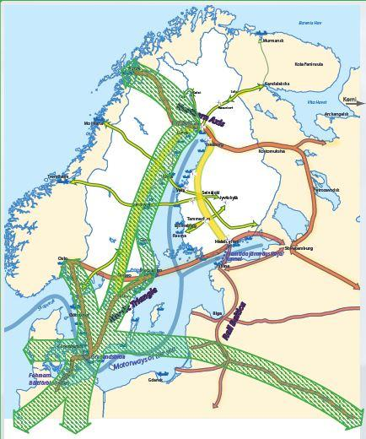
Figure 2 Green corridors is an initiative from the EU.

Examples of simulator usage in operational environments
For a functioning railway system, several functions and roles are necessary. A few of these are presented in this section. There is also a need to train and perform research on the complete railway system. However, this is both difficult and unsafe in the real world. That is why simulators are such valuable tools. The next subsections first describe how simulators can be used for training and research and then two practical examples of simulator use are presented.

Usage requirements for training tools vs research tools
The main objective with training is that the drivers´ learning progresses towards the learning goal. Training requires feedback and various levels of difficulty. There is also a need for variation within the same degree of difficulty. This means that the tools need to be flexible and adjustable. Of high importance is that the training provided by the tool is pedagogical and less important is that it is identical for all participants. There is a need for good provided feedback, to both driver and instructor, which should be clear in describing what has been achieved, progress over time, and where further training is needed.
A main goal within research is to examine effects of something on something, for example effects of training, implementation of a DAS-system or a changed speed profile on efficiency or punctuality. Thus, research requires a controlled environment with possibility to repeat the same scenario for numerous participants and record large amount of anonymous data. Receiving correct data for effect measures is of high importance and to be able to summarize or compare between groups or systems. Depending on the situation, both in training and research, the simulated environment needs to be at a certain reality level. An environment too advanced for the requirements, would be too expensive and may also limit the possibility to interact with the system.
Environment supporting both training and research
The requirements for training and research stated above, indicates that a flexible environment supporting both purposes is achievable. One strategy to meet this aim is to allow for choosing either training or research mode once the set-up of systems to include is made. Suggested parameters to adjust within the selected mode are for example: integrity, feedback, instructions, output data.

Train traffic dispatcher video exercises
This exercise aims to give train dispatchers (signalman – UK) an insight into, and increased understanding of, the train driver's reality based on some different scenarios. Exercises will give the students and trainees possibility to understand how the train traffic and safety management issues will be tackled in a nearly real operational environment using simulation tools. That will support the curriculum of the topics selected by the partners. This will help to build bridges between this exercise and other objectives of the DIGILOG-project.
For this exercise, a total of 8 videos were recorded in a simulator environment with a train driver who “think out loud” to facilitate the understanding of his actions. The films were recorded in a train simulator developed by VTI (the Swedish Road and Transport Research Institute) and used by several actors who conduct rail related education or rail traffic. There are discussion questions linked to each video. The videos can give better results if watched in groups of two or three people, as it enables the discussion.

Example of management of shunting operations
The use case concerns handling deviation in traffic. The simulators and systems involved are Train Driving Simulator (TDS), STEG (digital graph), RTTP (Real Time Traffic Plan), Deviation Handler (DH) and Arrival Yard Planning Tool. Actors involved are train driver and traffic controller.
1. Traffic controller gives clearance for starting to drive the train.
2. Train driver starts driving the train in the Train Driving Simulator (TDS).
3. Some disturbance occurs…. Train is delayed.
4. The traffic controller is, via STEG (digital graph), informed about the deviation from RTTP (Real Time Traffic Plan).
5. STEG updates the RTTP based on the current situation (without changing any order of trains or anything else – just shift trains in time according to updated forecast of arrival/departure times).
6. Traffic controller detects a reason to update the RTTP (e.g. a conflict or a delay or any other reason why RTTP should be updated).
7. Traffic controller asks the Deviation Handler (DH) for an updated RTTP.
(The Traffic controller can control how much the Deviation Handler can change the plan, priorities, level, etc., before asking for new RTTP).
8. Traffic controller receives a proposed new RTTP. The new RTTP is calculated by the Deviation Handler.
9. Traffic controller uses STEG to assess the proposed new RTTP.
Traffic controller adjusts the RTTP and confirms the usage of the new RTTP.
10. Train driver is informed about the new RTTP via the C-DAS.
11. Train driver adapts his/her driving according to the updated timetable for the train.
12. If the new RTTP results in some changed arrival times, updated arrival information is sent to the Arrival Yard Planning Tool.

Technical information and safety issues
Most train operators and train driver educators in Sweden use train driver simulators. These are developed at and purchased by the Swedish national road and transport research institute. Since 2015, a scheme for development of train simulators, based on the same proprietary simulator software and with existing Swedish tracks represented, has been successfully developed, based on user involvement and needs, with a main application in train driver education. During this process, agile methods (Agile Alliance, 2018) and user-centered systems design (UCSD) (Norman, 1986) have been employed. This development of joint collaborative development of train simulators in this fashion, is unique and has been shown very beneficial (Thorslund, Rosberg & Lindström, 2019).
The user group meet twice per year at each other’s sites. These are very similar as can be seen in Figure 3. The first companies to join the user group were train driver academies and they invested in passenger train simulators, like the one at VTI. Freight train operators waited for the freight train model to be established, which was performed during 2016 (Andersson, Lidström, Peters, Rosberg, & Thorslund, 2017). During the user meetings, knowledge is shared, and decisions are made on which developments that should be made. Examples of shared knowledge is special scenarios and ideas on how to structure test protocols.

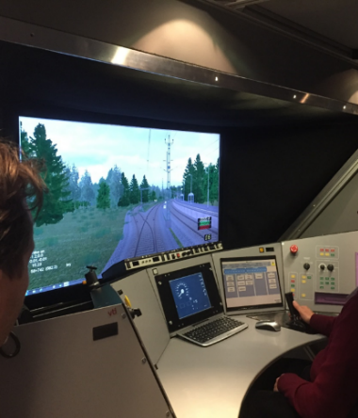 | 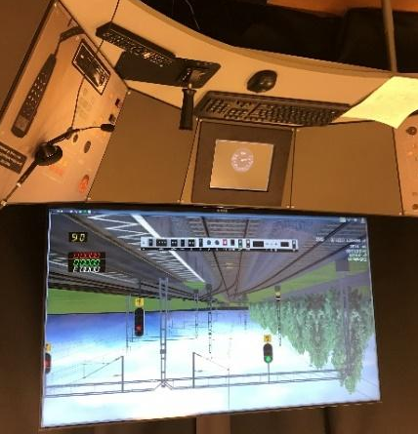 | 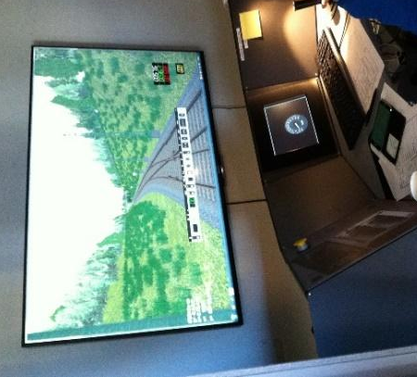
Figure 3 User meeting at 3 different sites. From the left; VTI, Nässjöakademin, and TCC.

The multiuser centred design in the user group is described in Figure 4. The main developing loop is driven by the TUFFA member group and has a 6-month cycle time from setting requirements and needs to delivery to train simulation code base. However, parallel with this activity there can be several UCSD processes driven by special customer needs. These activities have in general a shorter cycle time.
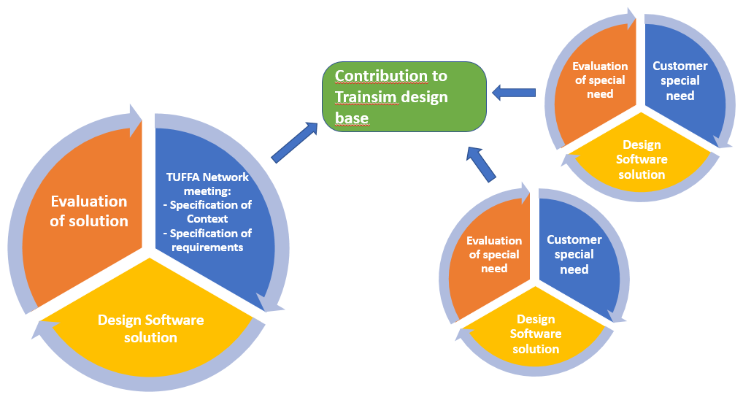
Figure 4: Multiuser design development in the TUFFA train simulation network.

The train simulation software has been developed based on the 12 principles behind the Agile manifesto (Agile Alliance, 2018). An agile way of working has been suitable. Thus, the close contact between software developers and train educators, lead to continuously feedback, which has been essential for a successful product and validation. Important has been to meet the ideas, changes and deliverables from the members. New functions shall not prevent other members to use the software in the way it was intended. On the opposite, these customer specific contributions should benefit all members in the group. This has also proved a successful way to promote collaboration between competitors.

Safety issues
The project of developing train simulators based on real Swedish track data has been examined for safety issues and approved by the Swedish transport administration under the following conditions:
- Video recording in the train is approved
- Video recording in traffic control centrals is not permitted unless a specific permission has been given by the Swedish transport administration.
- The Swedish transport administration shall receive all information regarding reports and other publications before disseminations. This is to provide safety classified information to be spread. om rapporter och publikationer innan publicering för att motverka att säkerhetsskyddad information sprids.
- The researchers must inform Swedish transport administration and ask for permission if any technical details regarding the tracks or traffic controls is to be published.

References
Agile Alliance. (2018). 12 Principles Behind the Agile Manifesto. Retrieved from: www.agilealliance.org
Andersson, A., Lidström, M., Peters, B., Rosberg, T., & Thorslund, B. (2017). Framtagning av loktågsmodell för VTI:s tågsimulator/Development of a freight train model for the VTI train simulator. Linköping: VTI.
Norman, D. (1986). Cognitive Engineering. i D. Norman, & S. Draper, User Centered Systems Design. Hillsdale, NJ: Lawrence Erlbaum Associates Inc.
Thorslund, B., Rosberg, T., & Lindström, A. (2019). User-centered development of train driver simulator for education and training. 8th International Conference on Railway Operations Modelling and Analysis (ICROMA 2019). Norrköping, Sweden, June 17-20, 2019.

