

Report of the results of Intellectual Output IO 1 (Status reports)
Result 2 and 3: Development quality criteria, assessment and feedback principles for e-supported T&L education
Jaana Kullaslahti and Tarjaleena Tuukkanen
Principles of Quality criteria for online implementations – the most important criteria, developed together with all partners. There are six themes and ten criteria: assignments (two criteria), contents and materials (one criterion), tools (two criteria), guidance and feedback (three criteria), evaluation (one criterion), usability, and visuals (one criterion). These criteria are based on and modified from the quality criteria of the Finnish eAMK project.
- Assignments (2) What kind of assignments?
  - The purpose, the objective, the procedure, the evaluation criteria, and the schedule of the assignments are clearly described on the online platform.
  - The assignments guide the students towards achieving the learning objectives of the course.
- Contents and materials (1) What kind of materials?
  - The online implementation utilises materials to which the institution has an access right. References and copyright information have been marked appropriately.
- Tools (2) What kind of tools?
  - Instructions for using the online platform and any applications and tools used, as well as creating a user account, are easy to understand and located on or linked to the online platform.
  - The course description lists the basic equipment required for completing the course, as well as other necessary applications.
- Guidance and feedback (3) How to give/get feedback?
  - The implementation is designed in a manner that enables the teacher, other students and stakeholders to provide guidance and feedback during the course.
  - The responsible persons, channels and schedules related to student guidance are described on the online platform.
  - The online platform has a channel for the students’ feedback and questions.
- Evaluation (1) How to evaluate?
  - The evaluation criteria are based on the learning outcomes of the course. The criteria and evaluation methods are detailed in the course description.
- Usability and visuals (1)
  - The applications selected for the online implementation work and the materials are accessible through all types of terminal devices.




There were gathered students’ feedback during the pilots, and the questionnaire based on the quality criteria. It included 17 statements, where students evaluate how well the quality criteria were implemented during the course, and one open-ended question. Twenty-two students answered the questionnaire, and the statements were agreed or lightly agreed. The students experienced pilots and especially simulations very interesting. Statements in the questionnaire:
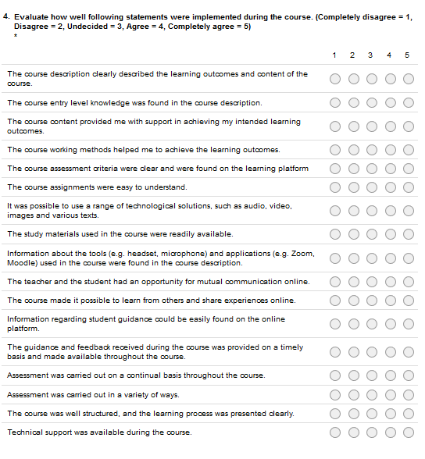
The survey was conducted as an online survey using Webropol survey and reporting tool.

Result 3: Development of methodological approach of cross-study and virtual team work for e-learning materials based on Carpe Diem learning design process
Jaana Kullaslahti and Tarjaleena Tuukkanen
Carpe Diem learning design process included:
- Five webinars & two workshops (2019)
- Teams worked with their own course/unit and prepared for the next webinar/workshop
- Two webinars (2020)
- Teams worked with their own course/unit and prepared for the next webinar/workshop and pilot
- Pilots started in spring 2020 and ended in fall 2020
We gathered feedback about the Carpe Diem methodology from all partners, and it was very positive:
- a useful way of working
- the process was logical and well structured
- fits well with the goals of institutional cross-study
- will help the study process and makes it visual for the students and teachers
- universities should share their know-how, more co-operation
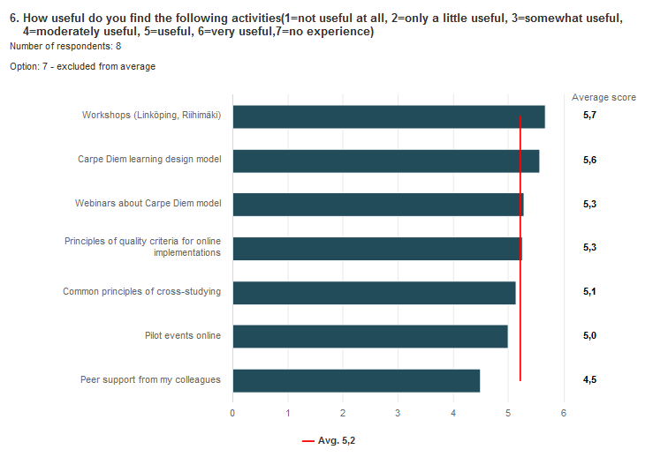
Before the pilots, all partners discussed and agreed on the first version about common principles for cross-studying. The next version will be published at the end of spring 2021. The first version:
- The partners will agree on which parts of the modules will be offered virtually. Each partner will offer at least one part of a module.
- The offered courses will be compiled on a joint website to be viewed by the students. The website will display implementation plans and registration instructions and the necessary tools and contact information.
- Students will ascertain the suitability of the studies to their study programmes at their respective universities or educational institutions
- Students will enroll at a university or educational institution offering the studies. This will involve filling out a form, available on the website, by the appointed deadline
- The implementation will involve a learning platform provided by the university or educational institution, and appointed tools will be used for working on the studies.
- During the implementation, the provider of a module or any part of it will assume responsibility for student guidance in terms of content and technique.
- The overall assessment of a module or part of it will be completed within one month after the module ends.
- The university in charge of implementation will forward each student assessment to the student’s home university or educational institution within one month after the module or part of it ends.

