


Results of intellectual output IO2

To achieve planned results of output IO2 following activities were implemented and reported:

1. The algorithm for TRELOGIC application for T&L VET was developed (Annex 1).
2. The content and set of information materials for TRELOGIC application for T&L VET was developed (Annex 2).
3. The educational information as essential background knowledge for TRELOGIC application was prepared (Annex 3).
4. The pilot software of the TRELOGIC system was designed (Annex 4).
5. The detailed TRELOGIC Manual in English was developed (Annex 5).
6. The TRELOGIC Manuals in the local languages of the partners were developed (Annex 6).
7. The video demo of TRELOGIC application was developed (Annex 7).

Annex 1.
The structure of TRELOGIC application and algorithm for TRELOGIC game based training for T&L VET
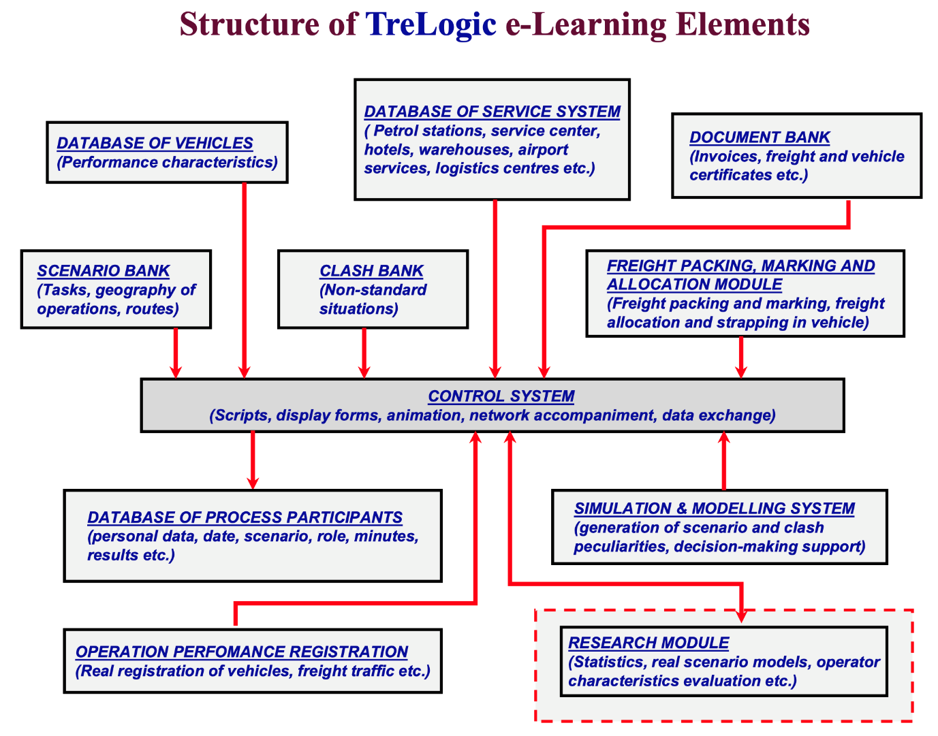






Methodological approach for game-based training
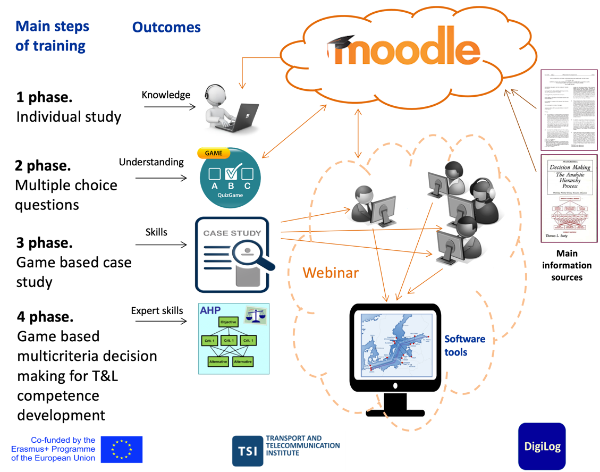

Annex 2.
The content and set of information materials for TRELOGIC application for T&L VET

Within the frame of IO2 each partner prepared set of national-oriented information materials for case studies, which will be used as background for game training in multinational environment of transport and logistics.
Each partner collect initial nation-oriented information kit needed for development case studies for IO2. This information kit includes the next core information:
- Three core objects of national transport and logistics infrastructure in various cities (sea and dry ports, raw or production hubs, logistics centres, and others), one of which should be obligatory sea port.
- For selected objects, indicate the structure of goods, their volume and the modes and types of transport means involved in their transportation.
- Free-form description of selected transport infrastructure objects.
- Web sites of objects of the selected transport infrastructure.
- For used modes and types of transport specify tariffs for transportation of various cargo.
- Specify the national characteristics of the customs conditions.
- Identify public and commercial information systems used to obtain information about the characteristics of the transportation of goods and their conditions in the territory of the partner countries.
- Specify the systems that provide service to track the location and status of cargo ot the territory of the partner country.

The composition of the information in the specified information kit can be updated in the process of performing work under practical use of game-based application.

Annex 3.
The educational information for TRELOGIC application

The educational information for TRELOGIC application is contained in the subject card “Game based multi-criteria decision making for T&L competence development” (file with title “Annex 3”).

Annex 4.
The pilot software of the TRELOGIC application

A software application has been developed. Examples of user interfaces ща application are shown below.

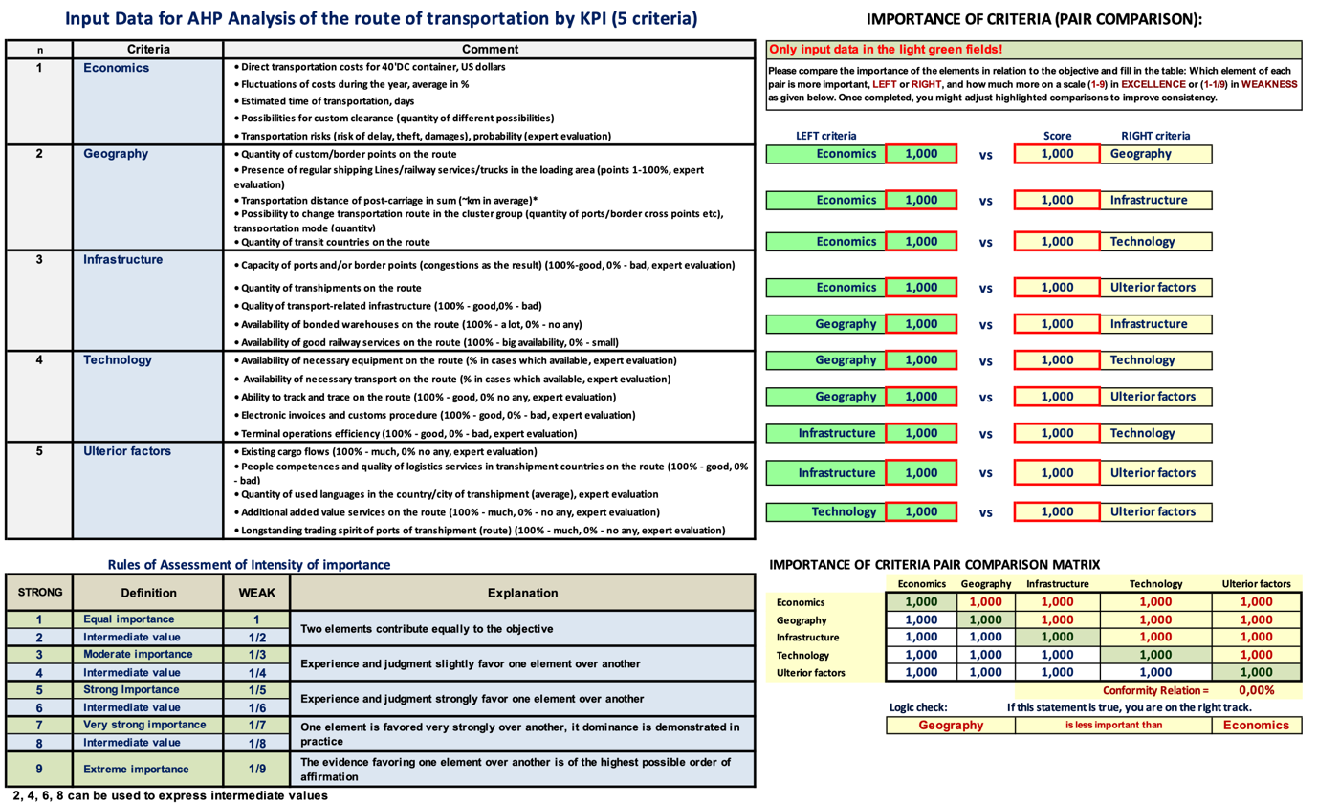

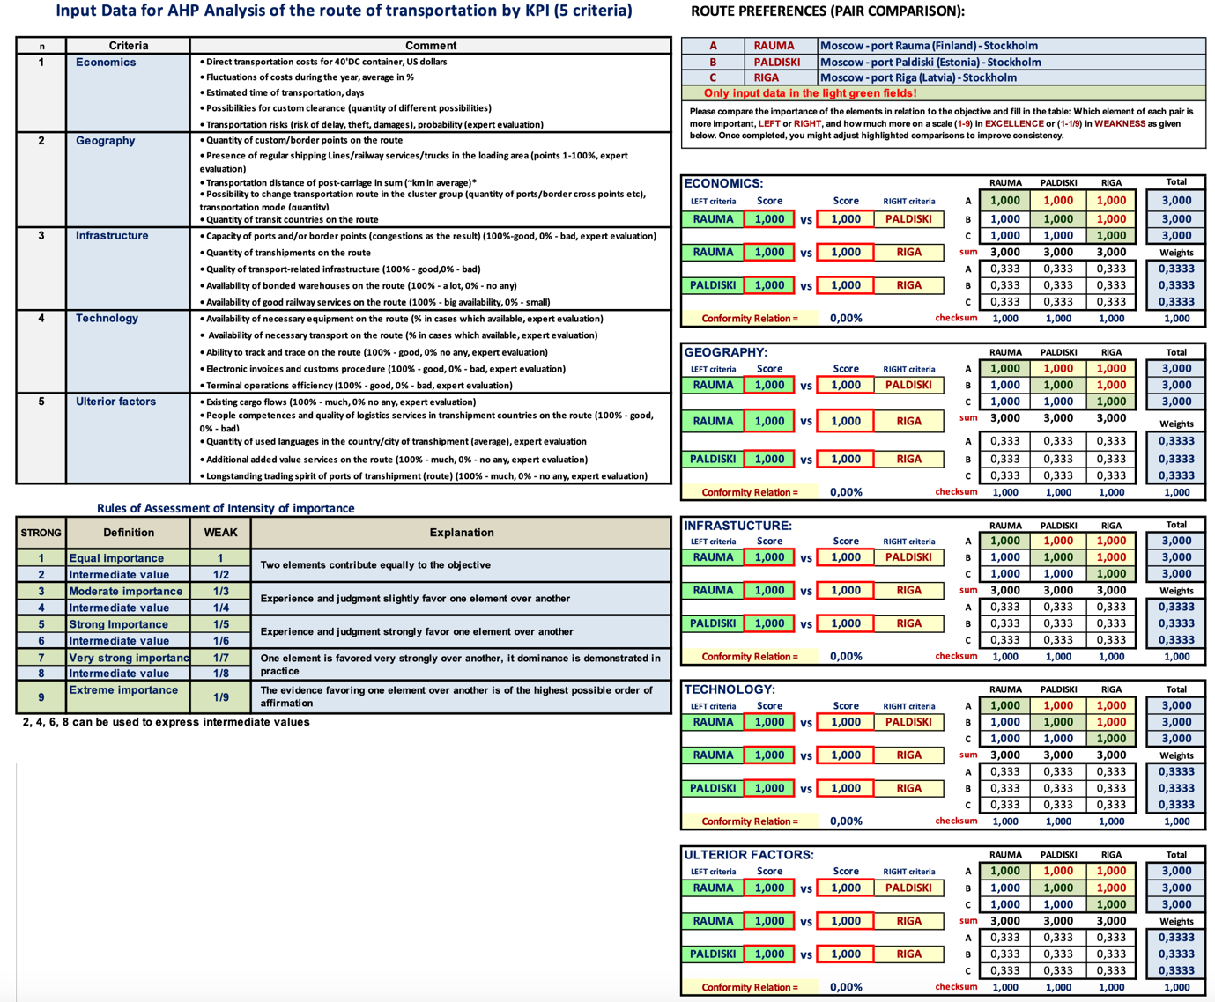

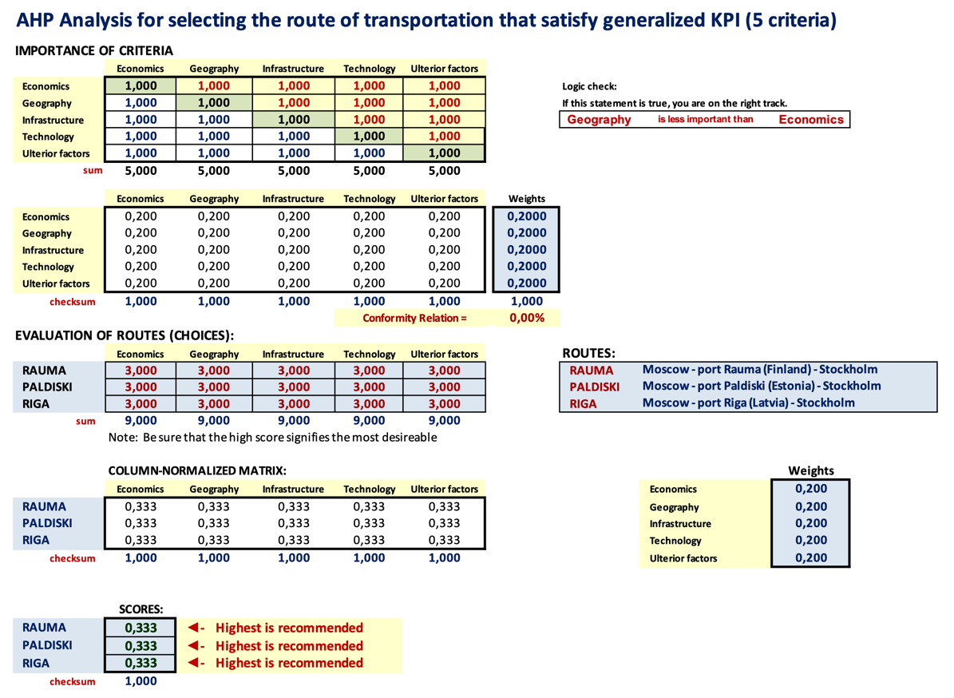

Annex 5.
The detailed TRELOGIC Manual in English

Guideline for use of E-learning game-based technology for training and education of transport and logistics specialists (TRELOGIC) is in the file with title “Annex 5”.

Annex 6.
The TRELOGIC Manuals in the local languages of the partners

The TRELOGIC Manuals in Estonian,Finnish, Latvian, Swedich languages included in files with titles “Annex 6”.

Annex 7.
The video demo of TRELOGIC application

The video demo of TRELOGIC application was developed. The file has size about 38 MB.
The file can be downloaded from the link:
https://www.dropbox.com/s/s9ccauqp7v94bna/VIDEO_AHP_TreLogic_DigiLog-2021.avi?dl=0

