Installation ETCS train simulator on Laptop

- Create a directory under C: Frame_Config
- Create a directory under C: VTI
- Copy TrainSim installation file from VTI-FTP area (log in details will be given up on request) and place in C: VTI directory
- Copy also file “frame.xml” and ”simulator.xml” and place in directory C: Frame_Config
- Run installation file, for example Visir-Botnia-1.0.2520
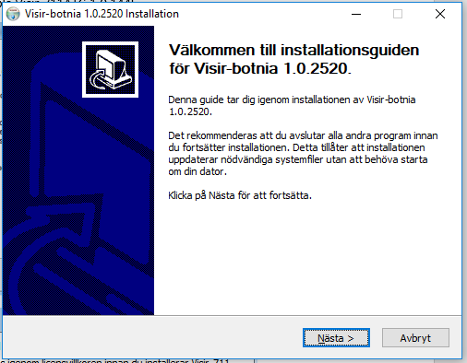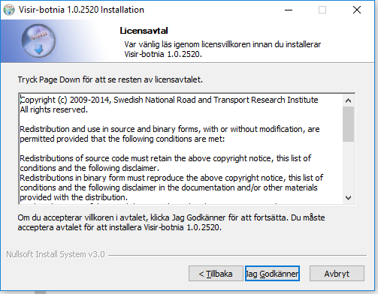

- Click ”Approve” – ”Jag Godkänner”
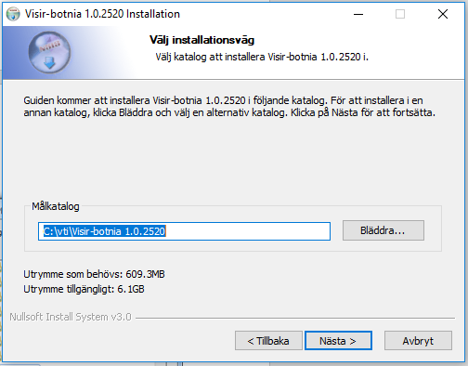
- Choose installation library (”Bläddra”), and when choosen click ”next”.
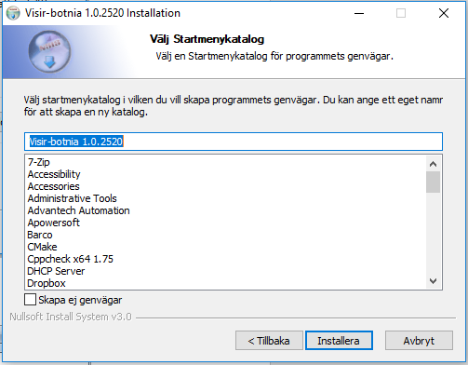
- Choose name of the installation library and click install (“Installera”).

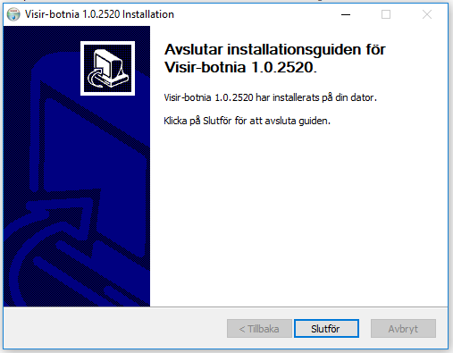
- Click finish ”Slutför”.
Directory Visir-botnia 1.0.2520 will be created under C:VTI
- Create shortcuts to the train sim executable file (visir.exe) and add to the windows desk. The file is placed under C:\VTI\Visir-Botnia 1.0.2520\bin\visir.exe.
- Do the same thing with TrainSim sound generator (Siren) executable (siren.exe). You find the file under C:\VTI\Visir-Botnia 1.0.2520\bin\siren\siren.exe.

